Bryanna Hardy

Task 4: Arm_Assembly

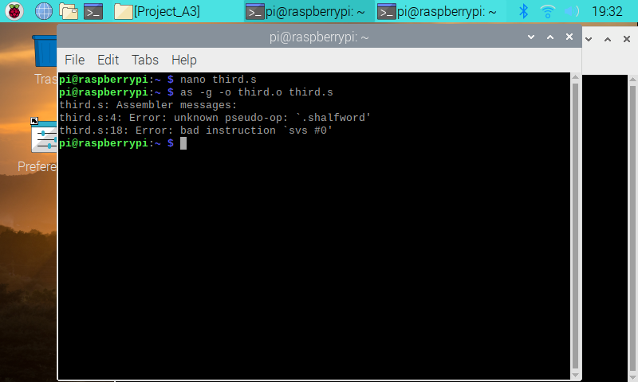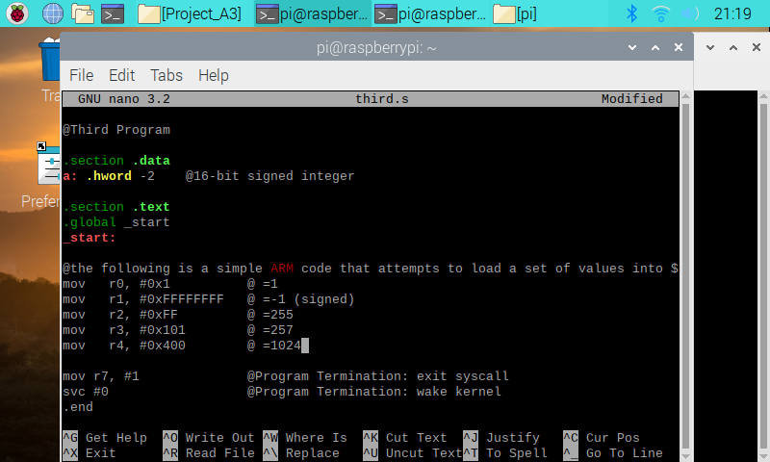

In the first image, there was an error because of the data type. “.shalfword” is not a correct datatype. To fix that, the correct datatype for half word is “.hword”. The second image is how the code is set up and coded into the hardware.

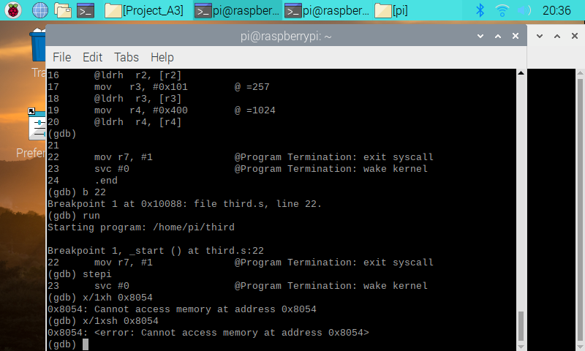

In this image, it shows that you cannot access the memory at both addresses with “s” which is unsigned half-word and “sh” signed half-word.

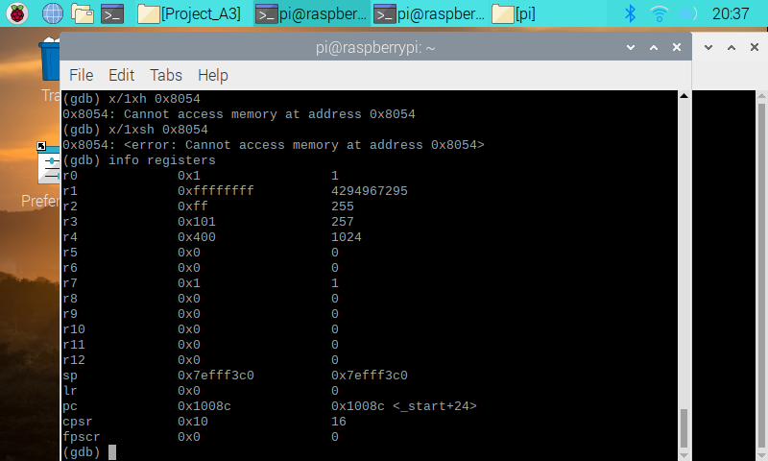

This image conveys the values of the registers that were initialized in the beginning.

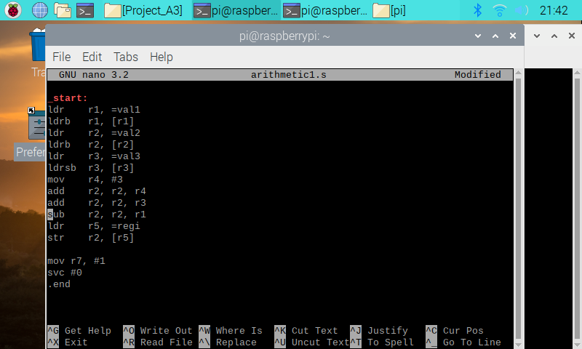 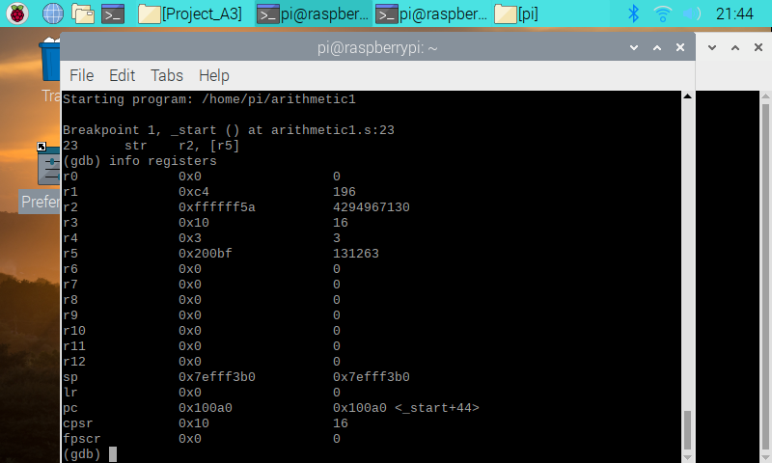

In this program, I had to program the equation “register = val2 + 3 + val3 - val1”. I used the tutorial to help me code this program correctly. At first, it was confusing and a little bit challenging to code with the new signed and unsigned initializations. It is very different from Intel x86 processors, where you would initialize if the value is a signed or unsigned. What was interesting to me, is how the values were stored in the registers, especially in r2 and r5.